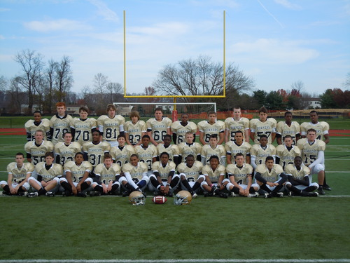
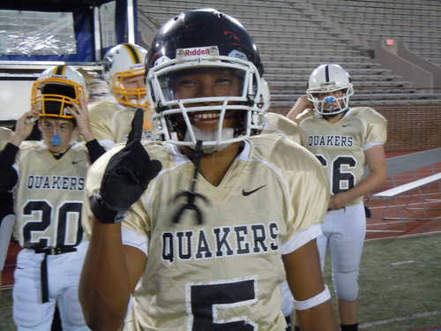
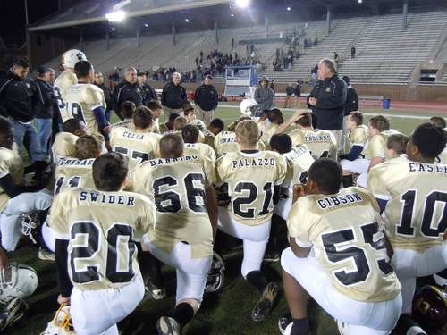
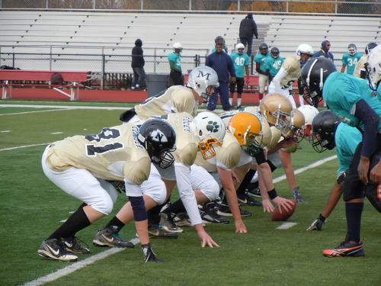
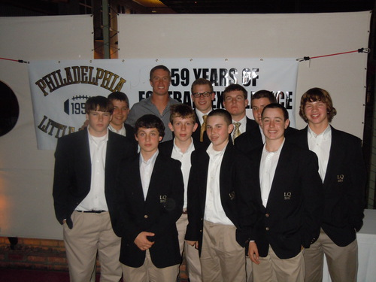

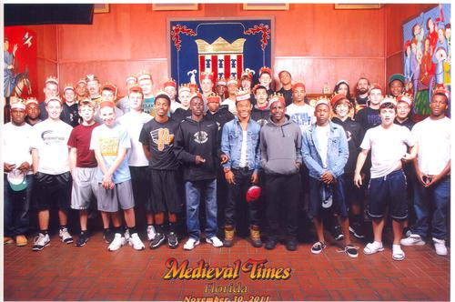
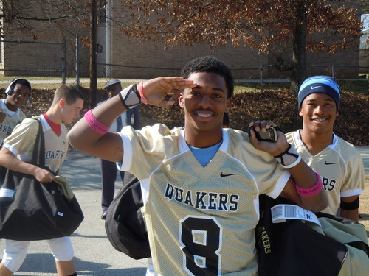
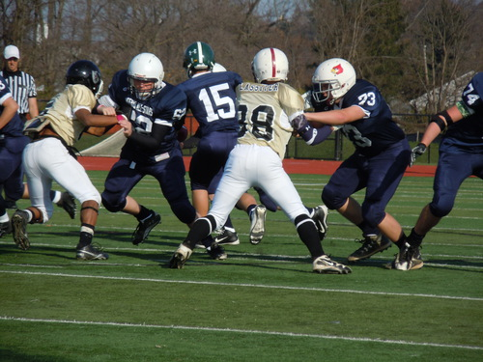
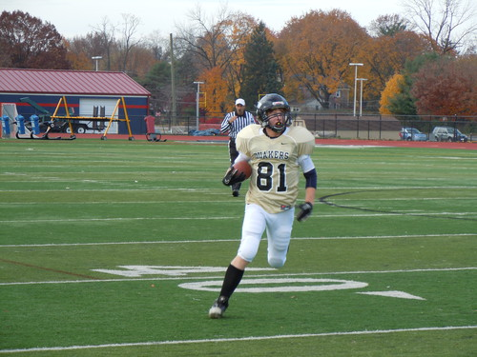
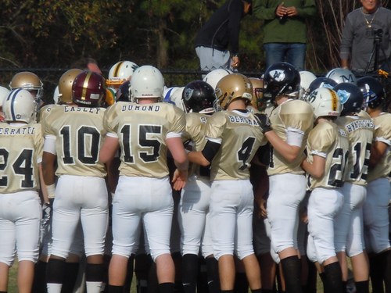
2011 Philadelphia Little Quaker
Team Banquet
PRICING:

* PLAYER: FREE
* Parents, Friends, Alumni: $40.00 Each
* LQ Patron: $100.00 Each
Instructions:
Please fill out order form and total the cost column. Mail payment and completed order form to address below. Tickets will be available at the door. For inquiries, please email Aimee at afara44@gmail.com

TICKET ORDER FORM

PLAYER NAME:___________________________________________

GUEST NAME: | COST:
TOTAL: _________

PLEASE MAKE CHECKS PAYABLE TO:
THE PHILADELPHIA LITTLE QUAKERS

MAIL TO:
PHILADELPHIA LITTLE QUAKERS
ATTN: AIMEE FARABAUGH
4200 MACALESTER STREET
PHILADELPHIA, PA 19124

